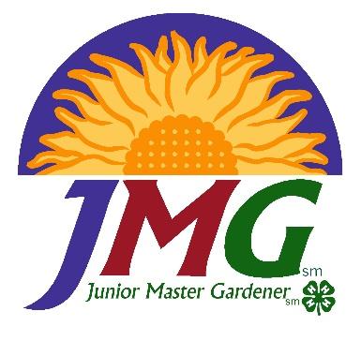**Indiana**

**Junior Master Gardener**

**Training Workshop**

## Thursday Sept. 30th, 2021

##### Noble County Extension Office

##### 2090 N State Road 9, Albion, IN 46701

##### mantissit

Come, Learn and Play!

This will be a hands-on training workshop designed to introduce and immerse you in the JMG curriculum in general with a focus on the Level 1 Curriculum, including Learn Grow Eat and Go materials. If you have your own copy of the JMG Level 1 and/or LGEG curriculum materials, bring them along. We will have a limited quantity to purchase on site.

Program Agenda

5:30 pm Registration

6:00-9:00 pm JMG Training Program

***$25.00 Registration fee*** includes workshop materials, lunch and light refreshments. JMG® Curriculum will be available to purchase the day of training. Please note: curriculum is not included in the registration fee. Purchase of these items is optional, you will have what is needed for training.

**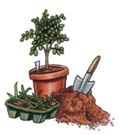***If you have any questions please contact*: Registration link: <https://cvent.me/lz1DNm>

**Dr. Kathryn Orvis**, [orvis@purdue.edu](mailto:orvis@purdue.edu)

765-426-2355 or 765-494-8432

615 Ag Mall Dr.; Dept HLA

West Lafayette IN 47992

Register by mail; or online at <https://cvent.me/lz1DNm>

Registration Form for: Indiana Junior Master Gardener Training Workshop, Sept. 30th

(Registration deadline: **Sept. 24th 2021**)

Name _________________________________________________ Phone ___­­_______________

Address __________________________ City _________________ State ______ Zip Code ________

County ________________________ E-Mail Address _______________________________________

***Purdue University is an equal opportunity/equal access employer. If you require auxiliary aids and services due to a disability, please contact us prior to the event at 765-494-8432 or orvis@purdue.edu***

Please send $25 and registration form to: Dr. Kathryn Orvis, 615 Ag Mall Dr., Dept. HLA, West Lafayette, IN 47907. Checks should be made payable to: Purdue University

Books available for purchase, limited quantities available. Payment is expected at time of pick up. We regret we are unable to take credit cards, cash or check only.

LGEG Curriculum Teacher Leader Guide JMG Level 1 Teacher/Leader Guide, 2016 update

$55 $60

LGEG Children’s books, set of 5 Youth Level 1 Handbook

$55 $20

Set of 25 LGEG Garden Journals LGEG completion pin

$40 $5

Set of 25 LGEG Garden Kitchen Recipes

$40